1. **Agenda**:
   1. How to create Docker images for our microservices account, loan, Card.
   2. How to run them.
2. 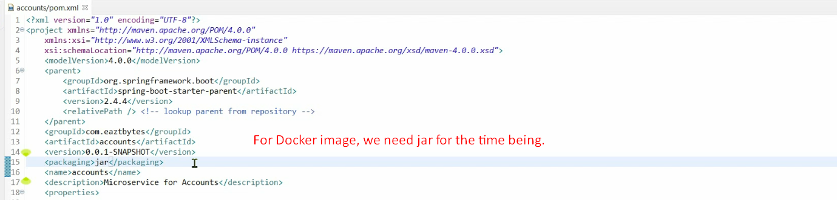**NOTE**: Here we’re talking about the JAR file that is created for the application.
3. 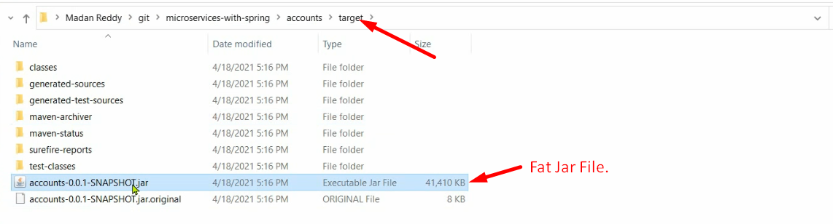
4. 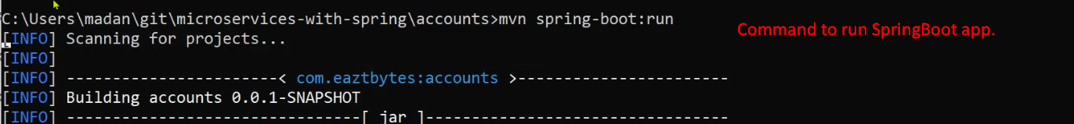
5. 
6. Let’s see the process of creating Docker Image.
7. Many ways to create a Docker image.
8. Let’s see the first lengthy way of creating Docker Image.
9. 